

Theresan Military Academy

Institute for Basic Officer Training

CMO Module A/B/C

Scenario

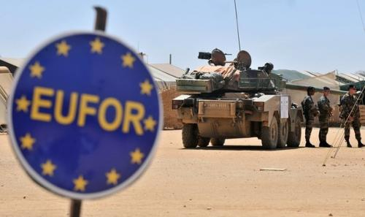

**2015**

**Remark:**

This scenario is created for exercise purposes only. The geopolitical situation is purely fictitious. Existing maps of real-life are used for the exercise because of availability. **They do not touch any political intent!**

|  |  |
| --- | --- |
| Drafter: | COL Harald GELL |
| Revised by: | LtCol Thomas LAMPERSBERGER |
| As of: | 29th of October 2015 |

### **1. Scenario**

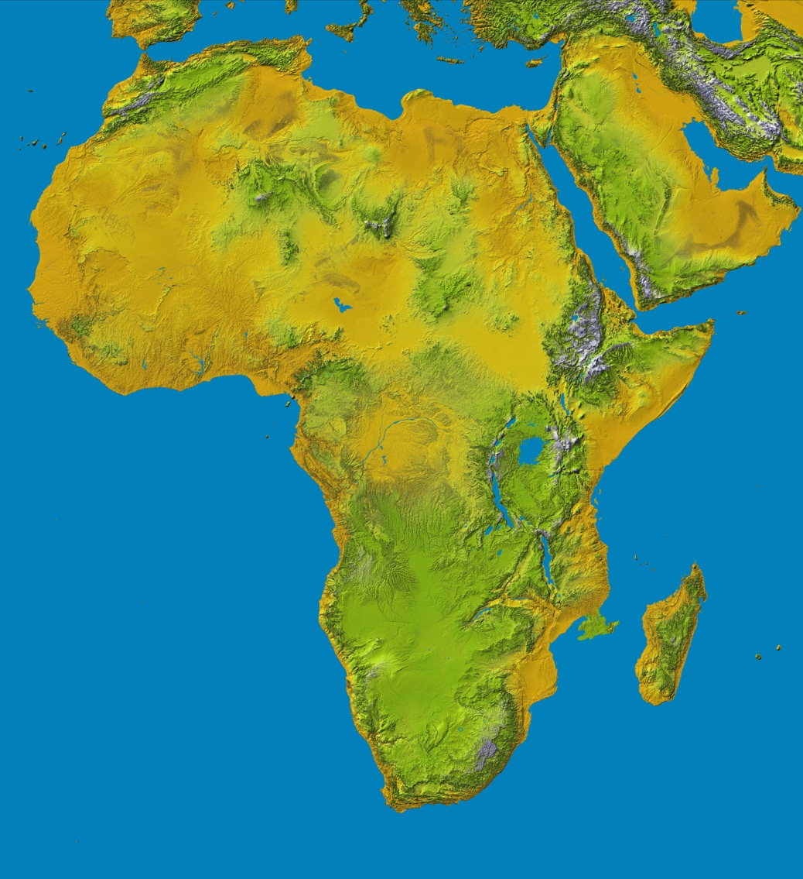 During the 19th century FERRA, was the centre of power on the MOFEPADOBECH Peninsula, located in the south-east of Africa.

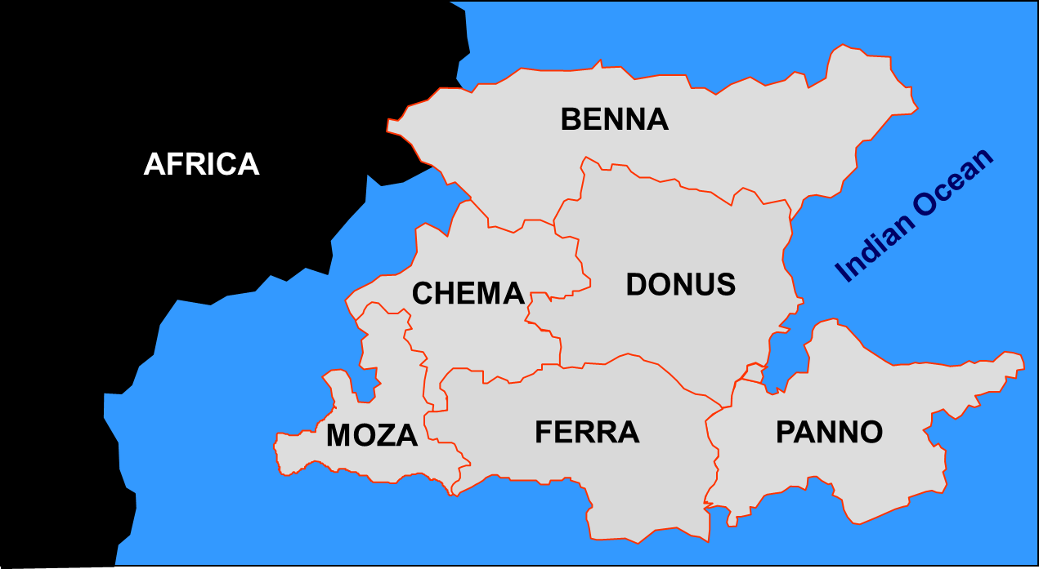

By and by FERRA occupied parts of neighbouring countries (MOZA, PANNO, DONUS, BENNA and CHEMA) until “GREATER FERRA” was proclaimed by the end of the 19th century.

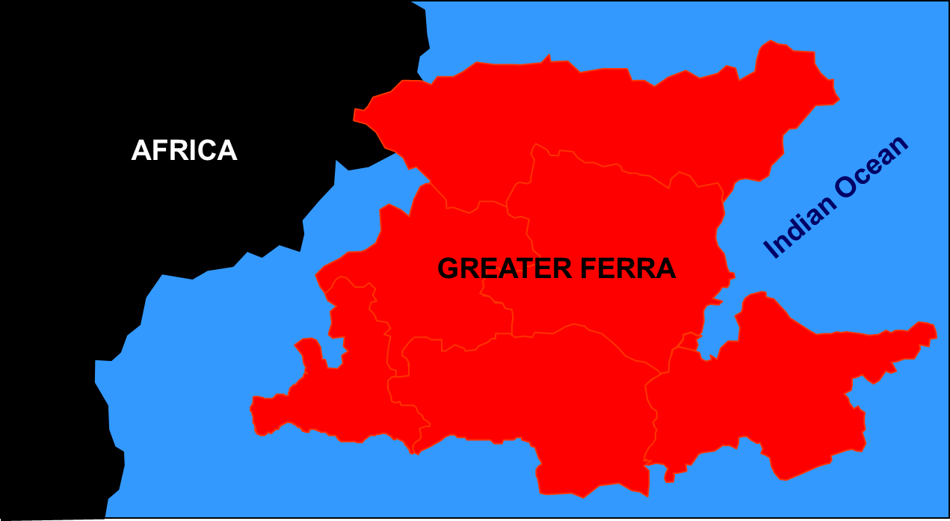

At the beginning of the 20th century, “GREATER FERRA” collapsed due to ethnic conflicts. “GREATER FERRA” was split up into sovereign states of FERRA, MOZA, PANNO, BENNA and CHEMA. Only DONUS remained linked with FERRA as a province.

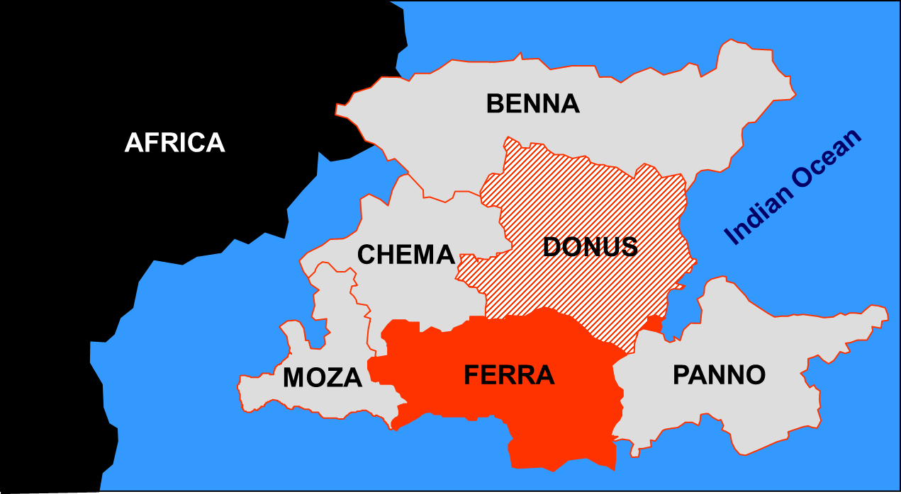

**2. Road to conflict**

During the 1950’s DONUS gained the status of an autonomous province, but the differences between the two ethnic groups remained.

In the 1990’s FERRA began to disintegrate along the ethnic line.

Finally DONUS declared its independence on 26th October 2014 and mobilized troops for a DONUS National Defence Force (**DNDF**) using personnel and equipment from former FERRA Armed Forces (**FAF**).

Some days later DONUS was internationally recognised by the international community as an independent state, followed by recognition of the UN.

The only by FERRA-ethnic group members populated municipality of MANDRARE remained as a part of FERRA, but without any connecting passage to the homeland (exclave).

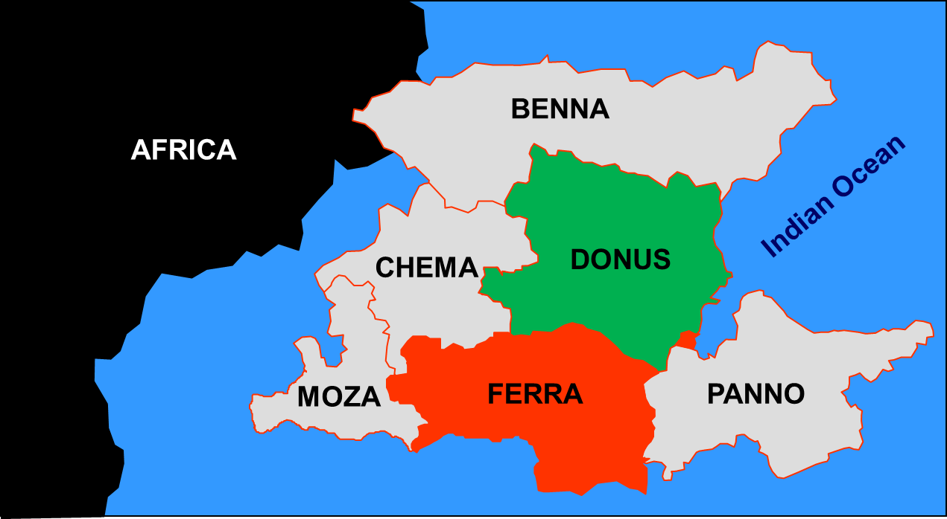

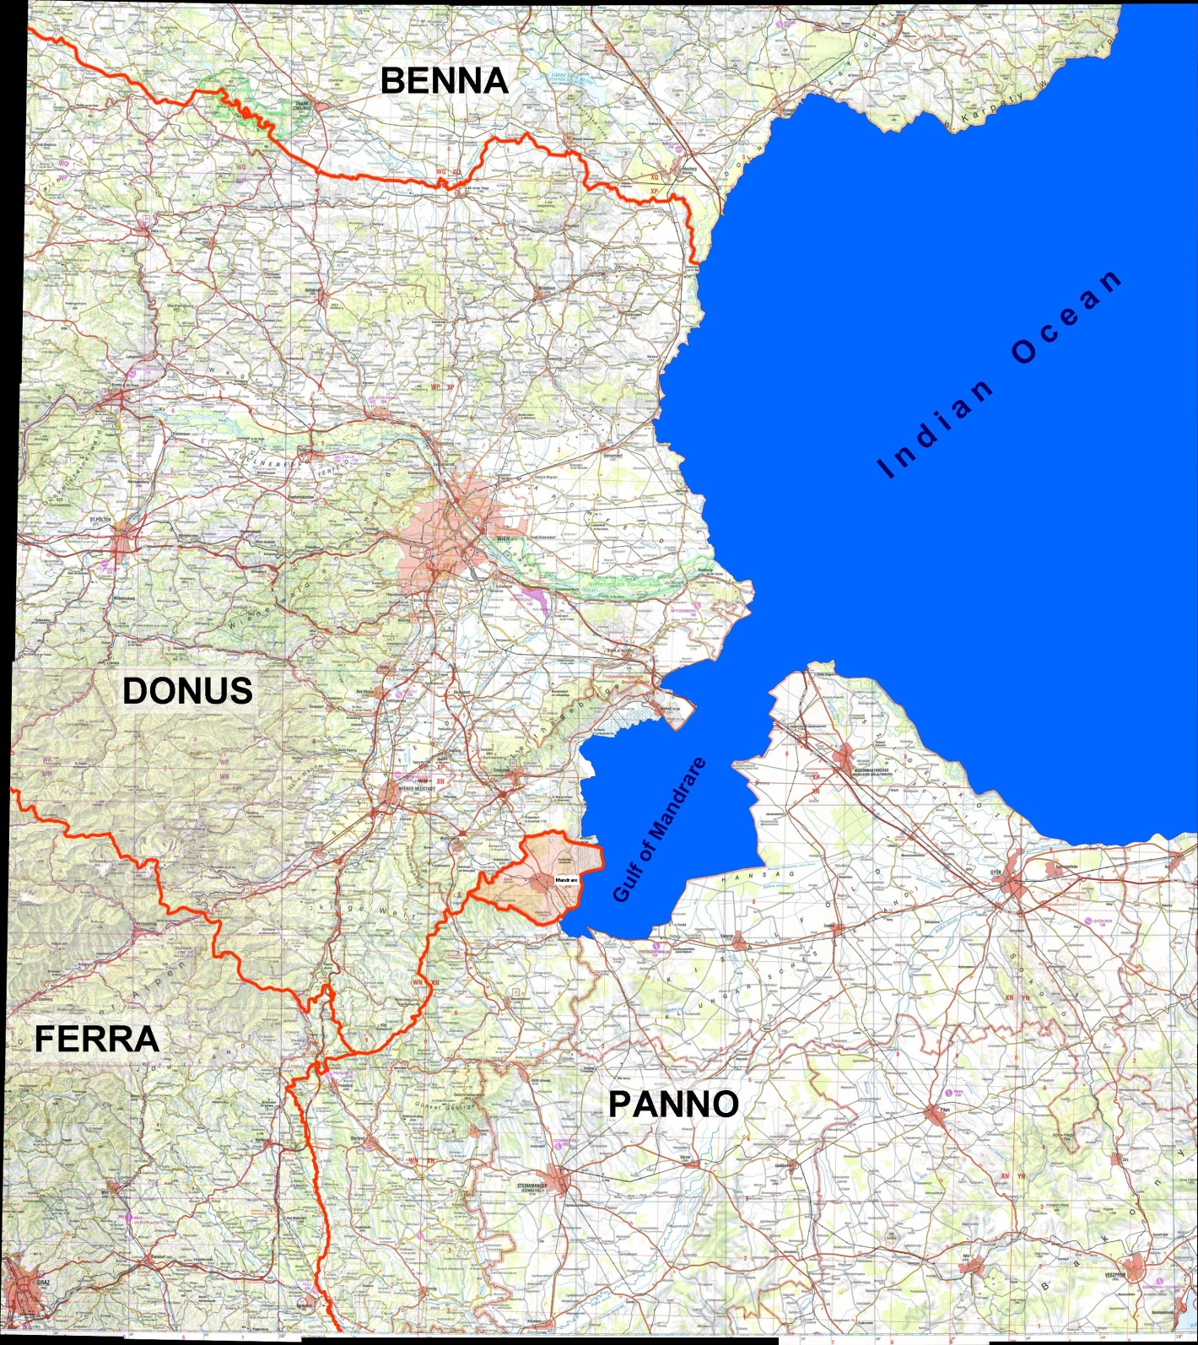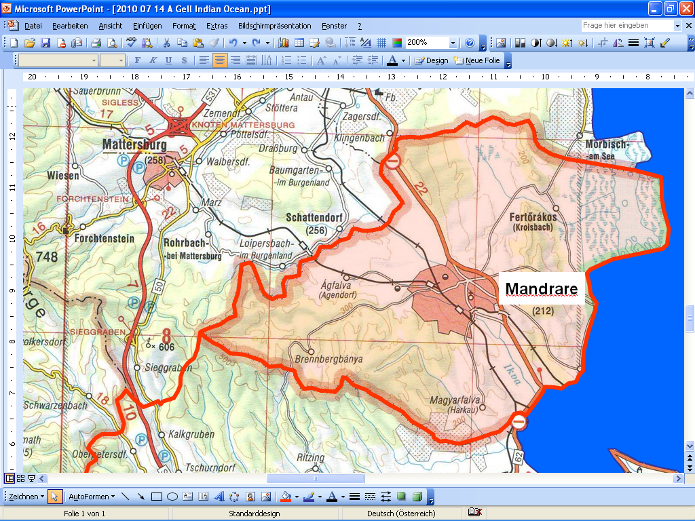

**MANDRARE exclave**

**is part of FERRA**

**3. Conflict in 2015**

In spring 2015, FERRA executed a military offensive against DONUS to reoccupy the country. One FAF Infantry Divisions and one Armoured Infantry Division attacked DONUS. One additional Armoured Infantry Division as the second echelon has not crossed the borderline.This offensive was supported by FERRA Air Force actions in the whole area of DONUS. The political aim was to reintegrate DONUS into FERRA. Tactical objectives focused on the destruction of DNDF and seizing key terrain (major cities, industrial areas and centres). The small and ill equipped DNDF fought bravely and stopped the FAF 40 km inside DONUS. During the conflict both parties extensively used obstacles, mines, antitank ditches, demolition of bridges and artillery delivered mines.

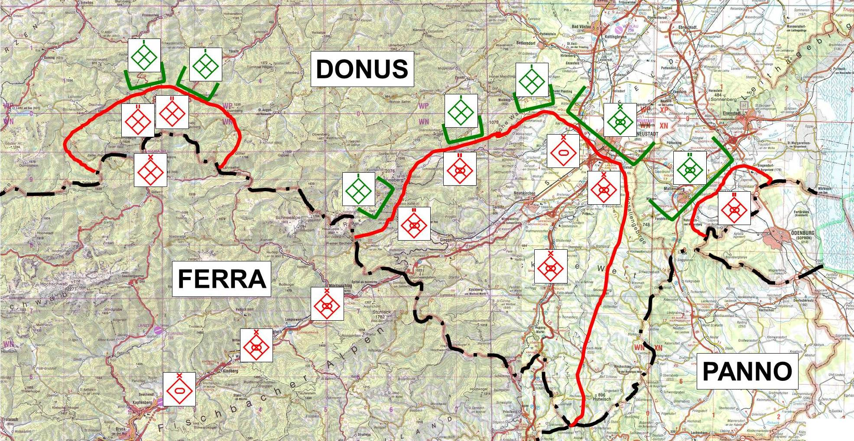

**4. UN/EU Peace in 2015**

With UNSCR 321-2015 the UN demanded the end of hostilities and threatened the FERRA government with UN sanctions.

On 1st October 2015 the warring factions agreed to the OSLO Peace Treaty. The military aspects, agreed upon in the GFAP (General Forces Agreement for Peace), required the opposing forces to halt along a Cease Fire Line (CFL) and to withdraw their forces accordingly.

UNSCR 323-2015 enabled the EU to commence a Crisis Management Operation (Peace Making) to implement the GFAP and to restore the national sovereignty of DONUS. The European Council agreed on leadership and major troop contributions. Name of the Force should be **EUFOR DONUS**.



**5. EUFOR DONUS Operational Timeline**

|  |  |  |  |  |  |  |
| --- | --- | --- | --- | --- | --- | --- |
| Phases | Deployment | | | | Separation | Stabilisation |
| D-Days |  | D-20 – D-1 | D | D+1 – D+9 | D+10 – D+69 | D+70 – |
| EUFOR DONUS | Transfer to the region | Marshalling and Staging in FMB MADAGASCAR | Secure SPODs | Debarkation of MNB SE at SPOD RUST and OGGAU  Debarkation of MNB C at SPOD HAINBURG  Establishing Concentration area IVO EISENSTADT | Establish interim AOS,  Establish MSZ & NFZ | Full operational capabilities and control of AOR established |
| DNDF | Cease fire  Start withdrawal to the north | | At D-Day:  DNDF-BN IVO MATTERSBURG  north of gridline 0 and west of gridline 1 | At D+9:  No DNDF-troops south of gridline 0 and east of gridline 1 | DNDF-troops in barracks | |
| FAF | Cease fire  Start withdrawal to the south | | At D-Day:  FAF-BN IVO MATTERSBURG withdrawled to MANDRARE | At D+9:  No FAF-troops north of gridline 9 and east of gridline 0, except 1 FAF-BN in the area of MANDRARE | At D+15:  No FAF-troops north of gridline 8 and east of gridline 9, exept 1 FAF-BN in the area of MANDRARE  At D+20:  No FAF-troops on DONUS territory  At D+25:  No FAF-troops within the AOL, except 1 INF-BN for border control tasks | South of AOL except 1 INF-BN for Border Security and 1 BN in MANDRARE |

**Remarks:**

|  |  |  |  |
| --- | --- | --- | --- |
| D-Day | The day when the operation starts | AOL | Area of Limitation |
| SPOD | Seaport of disembarkation | AOS | Area of Separation |
| MSZ & NFZ | Maritime Separation Zone and No Fly Zone |  |  |

**6. OPlan for the Stabilisation Phase**

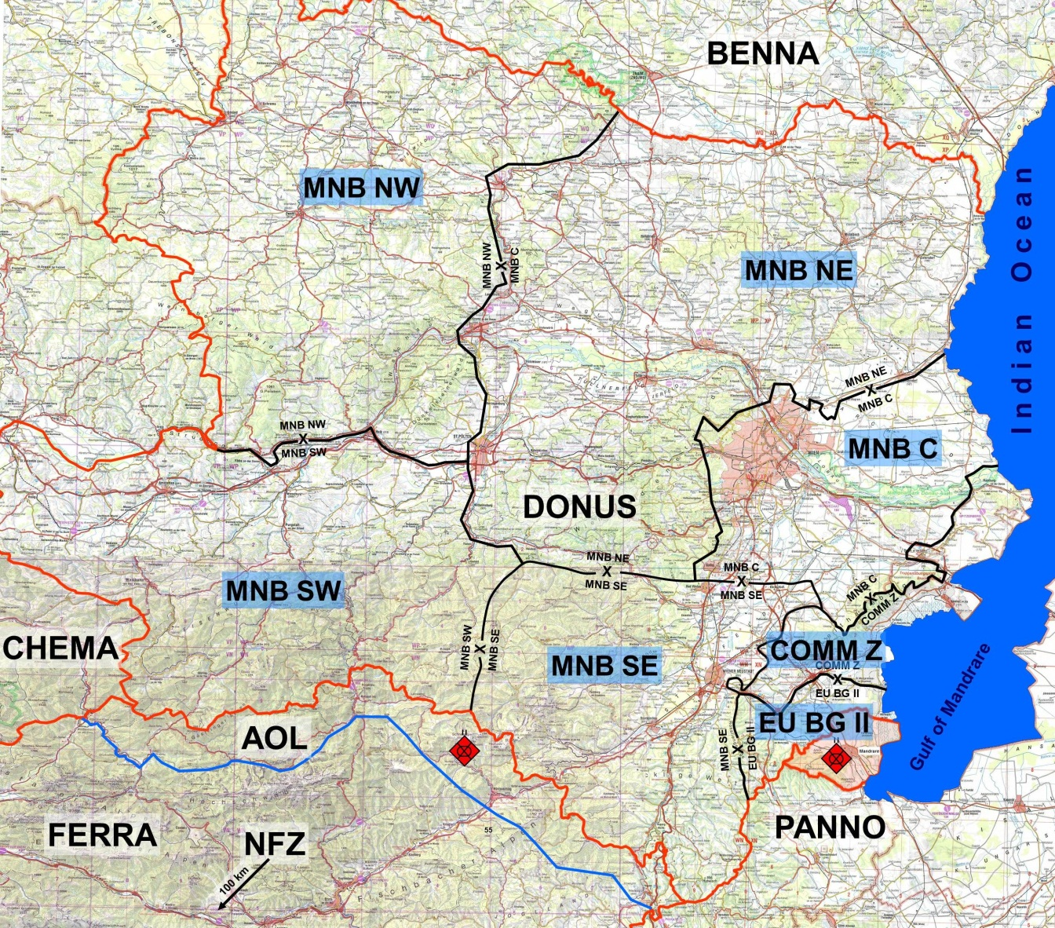

**Remarks:**

|  |  |  |  |
| --- | --- | --- | --- |
| D-Day | The day when the operation starts | COMM Z | Communication Zone (rear part of the area of operations) |
| SPOD | Seaport of disembarkation | AOS | Area of Separation |
| MSZ & NFZ | Maritime Separation Zone and No Fly Zone | AOL | Area of Limitation |

**8. Situation in the region**

The population of DONUS generally welcomes the international efforts. During the conflict in some areas war crimes against DONUS population took place. Because of that thousands of DONUS inhabitants of the border regions fled to the North who see the chance to return to a save environment.

Also most of FERRA minorities in DONUS welcome EUFOR DONUS because of securing them from DONUS population’s revenge, especially in and around MANDRARE.

Even before and especially during the conflict the ethnicities attacked houses and sites of each other. The most violent incidents took place in:

|  |  |
| --- | --- |
| KLINGENBACH (1589), | NATSCHBACH (8284), |
| HASCHENDORF (0004) | NEURISSHOF (9709), |

There are two irregular factions in the region that will remain even when the regular forces will withdraw and EUFOR DONUS will start its operation.

* **MANDRARE LIONS (ML):**

They are in favour of FERRA and operate from their base in MANDRARE. They started to hire a lot of FERRA ethnic people in DONUS to follow their political aim, the reunification of DONUS and FERRA. So far they succeeded in creating terrorist-cells in the villages of NATSCHBACH, PRIGGLITZ, HÖLLES, NEURISSHOF and AUSSIEDLERHÖFE. They announced in advance to fight against EUFOR DONUS from the very beginning.

* **PURE DONUS (PD):**

They are in favour of DONUS and operate in the whole area of DONUS. Their aim is to banish all the FERRA ethnic population from DONUS. Officially they welcomed EUFOR DONUS but in reality they will start attacks against FERRA population in DONUS in those areas where EUFOR DONUS is not able to protect them.

MOZA, PANNO, BENNA and CHEMA remained neutral during the war. They secured their borders with forces. Because of their fear to be probably involved in future conflicts these four countries did not allow any attempts of EU or UN to operate from their territories with international forces.

**9. Org-Chart European Union Battle Group (EU BG I)**

**10. Org-Chart European Union Battle Group (EU BG II)**



**10. Org-Chart Land Component Command (LCC)**



**11. Org-Chart FERRA Bn in MANDRARE and Bn for border security**

